TYPE OF SALE: 1690

Liquid-to-Liquid Coolant Distribution Unit (CDU)

Performance Features
- High thermal performance with a robust brazed plate heat exchanger where the standard model features an optimized design that delivers a nominal capacity of 1.35 MW at 4°C ATD, and supports a broader range of capacities under varying operating conditions.
- High secondary external pressure capabilities with single or optional dual pumps with integral variable frequency drives (VFD)
- Secondary fluid circuit filters with standard 25-micron in-line filters on the secondary side. An optional 50-micron filter is also available for selection.
- Hot swapable components, such as the secondary filters, pumps, and temperature and pressure sensors
- Sensor redundancy
- Low pressure drop design
- Integrated SmartVu™ controls and human machine interface (HMI) standard
- Integrated hydronic options such as temperature control valves, bypass valves and pressure control valves.
- Optional expansion tanks to help prevent over pressurizing the secondary system.
- Optional automatic transfer switch (ATS) that will automatically allow the unit to switch to a backup power source.
- Optional uninterrupted power supply (UPS) enables continuous operation in the control board, HMI and temperature control valve.
- Optional feature that automatically maintains the secondary loop’s volume by supplying makeup fluid from an integrated tank whenever the system detects a drop in pressure or fluid level.
The Carrier 65LL Coolant Distribution Unit (CDU) delivers an efficient, direct-to-chip liquid cooling solution for modern data centers. It is designed to keep facility and technology cooling fluid separate, helping to maintain the high fluid quality needed for sensitive equipment. With advanced thermal management features, the CDU supports reliable, energy-efficient, and sustainable heat removal. Its modular design and hot-swappable components allow for scalable deployment, continuous operation, and simplified maintenance.

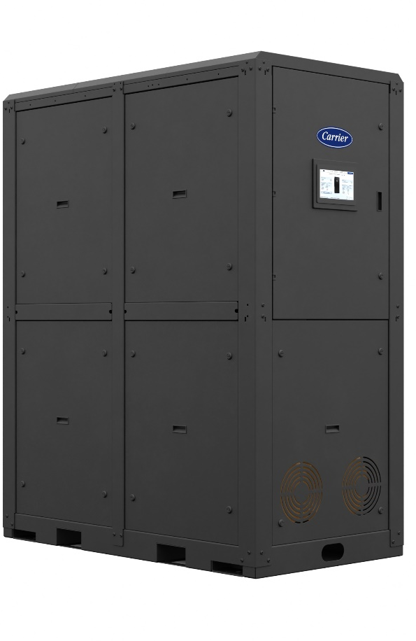

PC111 FORM NO. 65LL-2PPG
SUPERSEDES
PRICE SECTION 65LL-1PPG
)
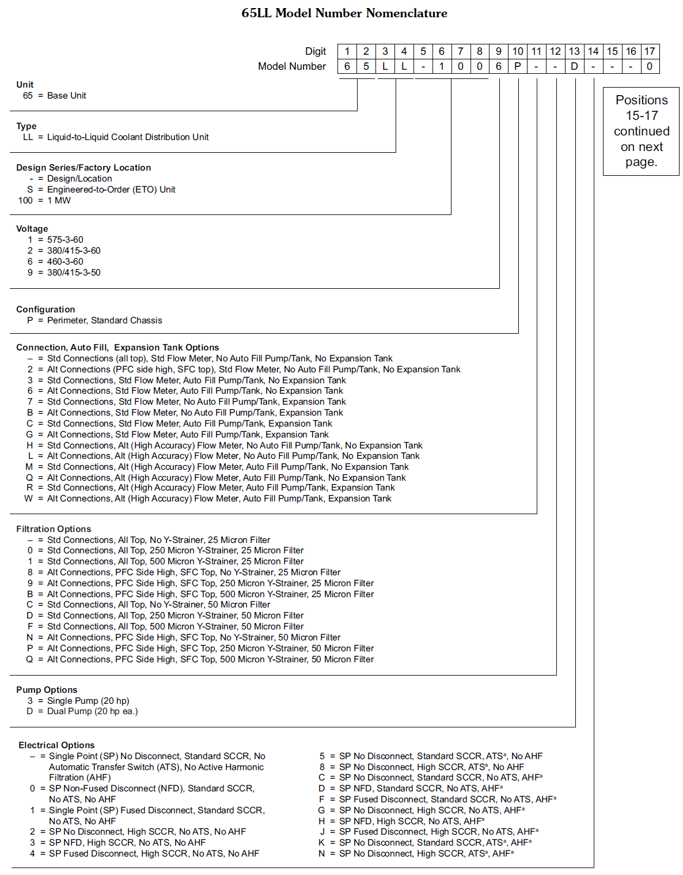

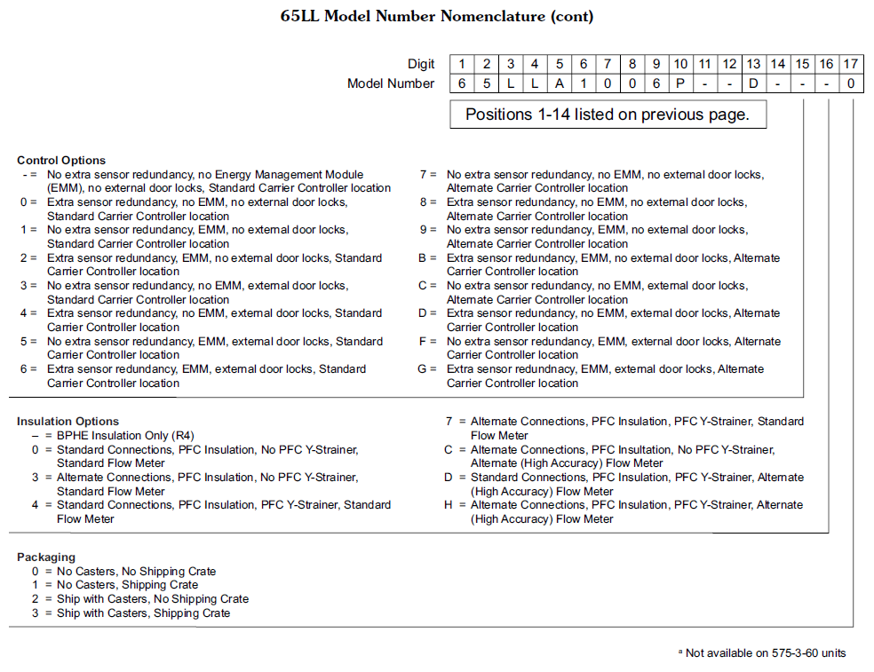

BASE UNIT MASTER PRICES
ORDERING NUMBER | VOLTAGE-PHASE-HZ | CAPACITY | PUMP QTY | HEAT EXCHANGER QTY | MASTER PRICE
65LL-1001P--3---0 | 575-3-60 | 1MW | 1 | 1 | 274,374
65LL-1002P--3---0 | 380/415-3-60 | 1MW | 1 | 1 | 274,374
65LL-1006P--3---0 | 460-3-60 | 1MW | 1 | 1 | 266,383
65LL-1009P--3---0 | 380/415-3-50 | 1MW | 1 | 1 | 279,862
65LL-1001P--D---0 | 575-3-60 | 1MW | 2 | 1 | 314,873
65LL-1002P--D---0 | 380/415-3-60 | 1MW | 2 | 1 | 314,873
65LL-1006P--D---0 | 460-3-60 | 1MW | 2 | 1 | 305,702
65LL-1009P--D---0 | 380/415-3-50 | 1MW | 2 | 1 | 321,170
65LL-1021P--3---0 | 575-3-60 | 1MW | 1 | 2 | Future offering
65LL-1022P--3---0 | 380/415-3-60 | 1MW | 1 | 2 | Future offering
65LL-1026P--3---0 | 460-3-60 | 1MW | 1 | 2 | Future offering
65LL-1029P--3---0 | 380/415-3-50 | 1MW | 1 | 2 | Future offering
65LL-1021P--D---0 | 575-3-60 | 1MW | 2 | 2 | Future offering
65LL-1022P--D---0 | 380/415-3-60 | 1MW | 2 | 2 | Future offering
65LL-1026P--D---0 | 460-3-60 | 1MW | 2 | 2 | Future offering
65LL-1029P--D---0 | 380/415-3-50 | 1MW | 2 | 2 | Future offering

Position 11
Connection, Auto Fill, Expansion Tank Options
11th DIGIT ORDER CODE | CONNECTION | FLOW METER | AUTO FILL PUMP/TANK | EXPANSION TANK | MASTER PRICE
 |  |  |  |  | 1MW
- | Standard | Standard | None | None | Std
2 | Alternate | Standard | None | None | Future Offering
3 | Standard | Standard | Included | None | 4,036
6 | Alternate | Standard | Included | None | Future Offering
7 | Standard | Standard | None | Included | 3,037
B | Alternate | Standard | None | Included | Future Offering
C | Standard | Standard | Included | Included | 7,072
G | Alternate | Standard | Included | Included | Future Offering
H | Standard | High Accuracy | None | None | 16,195
L | Alternate | High Accuracy | None | None | Future Offering
M | Standard | High Accuracy | Included | None | 20,230
Q | Alternate | High Accuracy | Included | None | Future Offering
R | Standard | High Accuracy | Included | Included | 23,267
W | Alternate | High Accuracy | Included | Included | Future Offering

Position 12

Connection and Filter Options
12th DIGIT ORDER CODE | CONNECTION | Primary Y Strainer (micron) | Secondary Fitler (micron) | MASTER PRICE
 |  |  |  | 1MW
- | Standard | None | 25 | Std
0 | Standard | 250 | 25 | 16,468
1 | Standard | 500 | 25 | 16,466
8 | Alternate | None | 25 | Future Offering
9 | Alternate | 250 | 25 | Future Offering
B | Alternate | 500 | 25 | Future Offering
C | Standard | None | 50 | 0
D | Standard | 250 | 50 | 16,468
F | Standard | 500 | 50 | 16,466
N | Alternate | None | 50 | Future Offering
P | Alternate | 250 | 50 | Future Offering
Q | Alternate | 500 | 50 | Future Offering

Position 13
Pump Options
13th DIGIT ORDER CODE | PUMP QUANTITY | MASTER PRICE
13th DIGIT ORDER CODE | PUMP QUANTITY | 1MW
3 | 1 | Std.
D | 2 | See Base Unit Master Prices

Position 14
ELECTRICAL OPTIONS
14th DIGIT ORDER CODE | POWER CONNECTION | DISCONNECT | SCCR | ATSª | AHFª | MASTER PRICE
 |  |  |  |  |  | 1MW
- | Single point (SP) | None | Standard | None | None | Std
0 | SP | Non-Fused (NFD) | Standard | None | None | 2,155
1 | SP | Fused (FD) | Standard | None | None | 4,989
2 | SP | None | High | None | None | 693
3 | SP | NFD | High | None | None | 2,848
4 | SP | FD | High | None | None | 5,682
5 | SP | None | Standard | Included | None | 11,021
8 | SP | None | High | Included | None | 11,713
C | SP | None | Standard | None | {13}=3 | 19,067
 |  |  |  |  | {13}=D | 38,133
D | SP | NFD | Standard | None | {13}=3 | 21,222
 |  |  |  |  | {13}=D | 40,288
F | SP | FD | Standard | None | {13}=3 | 24,056
 |  |  |  |  | {13}=D | 43,122
G | SP | None | High | None | {13}=3 | 19,759
 |  |  |  |  | {13}=D | 38,826
H | SP | NFD | High | None | {13}=3 | 21,914
 |  |  |  |  | {13}=D | 40,981
J | SP | FD | High | None | {13}=3 | 24,748
 |  |  |  |  | {13}=D | 43,815
K | SP | None | Standard | Included | {13}=3 | 30,087
 |  |  |  |  | {13}=D | 49,154
N | SP | None | High | Included | {13}=3 | 30,780
 |  |  |  |  | {13}=D | 49,847

Notes
Standard SCCR is 25kA @ 480V / 14kA @ 600V
High SCCR is 65kA @ 480V / 25kA @ 600V
ª Not available on 575-3-60

Position 15

CONTROL OPTIONS
15th DIGIT ORDER CODE | EXTRA SENSOR REDUNDANCY | ENERGY MANAGEMENT MODULE (EMM) | EXTERNAL LOCKS | CONTROLLER LOCATION | MASTER PRICE
 |  |  |  |  | 1MW
- | None | None | None | Standard | Std
0 | Included | None | None | Standard | 6,896
1 | None | Included | None | Standard | 1,618
2 | Included | Included | None | Standard | 8,513
3 | None | None | Included | Standard | 336
4 | Included | None | Included | Standard | 7,232
5 | None | Included | Included | Standard | 1,954
6 | Included | Included | Included | Standard | 8,850
7 | None | None | None | Alternate | 498
8 | Included | None | None | Alternate | 7,393
9 | None | Included | None | Alternate | 2,115
B | Included | Included | None | Alternate | 9,011
C | None | None | Included | Alternate | 834
D | Included | None | Included | Alternate | 7,730
F | None | Included | Included | Alternate | 2,452
G | Included | Included | Included | Alternate | 9,347
Notes
Alternate controller location is on the side of the unit

Position 16
PRIMARY LOOP PIPING INSULATION OPTIONS
16th DIGIT ORDER CODE | CONNECTIONS | INSULATION | Y-STRAINER | FLOW METER | MASTER PRICE
 |  |  |  |  | 1MW
- | Standard | BPHE only | None | Standard | Std
0 | Standard | Internal Primary Loop Piping + BPHE | None | Standard | 1,866
3 | Alternate | Internal Primary Loop Piping + BPHE | None | Standard | Future Offering
4 | Standard | Internal Primary Loop Piping + BPHE | Included | Standard | 2,366
7 | Alternate | Internal Primary Loop Piping + BPHE | Included | Standard | Future Offering
C | Alternate | Internal Primary Loop Piping + BPHE | None | High Accuracy | Future Offering
D | Standard | Internal Primary Loop Piping + BPHE | Included | High Accuracy | 2,616
H | Alternate | Internal Primary Loop Piping + BPHE | Included | High Accuracy | Future Offering

Position 17
PACKAGING
17th DIGIT ORDER CODE | CASTERS | SHIPPING CRATE | MASTER PRICE
17th DIGIT ORDER CODE | CASTERS | SHIPPING CRATE | 1MW
0 | None | None* | Std
1 | None | Included** | 1,651
2 | Included | None* | 2,808
3 | Included | Included** | 4,459

*Units will ship with a bag enclosure and will ship via dry van. These are not available for OP8
**Crate units can ship via low boy flat bed

OPTIONAL EXTENDED WARRANTIES ARE AVAILABLE. SEE CATALOG NO. 500-089
"COMMERCIAL START-UP AND OPTIONAL EXTENDED WARRANTY PRICING"

LEGEND
Std — Standard
Alt – Alternative
N/A — Not Applicable
NC — No Charge
CDU – Coolant distribution unit
VFD – Variable frequency drive
ATD – Approach temperature difference
HMI – Human machine interface
ATS – Automatic transfer switch
UPS – Uninterrupted power supply
ETO – Engineered to order
PFC – Primary fluid circuit
SFC – Secondary fluid circuit
SP – Single point
NFD – Non-fused disconnect
AHF – Active harmonic filter
EMM – Energy management module
BPHE – brazed plate heat exchanger
SCCR – Short circuit current rating

